A Secure intrusion detection against DDOS attack in Mobile Ad hoc network
S. Jerome, M. Dharunpandi, M. Harish kumar
Electronics and communication Engineering
Sethu institute of technology, Kariapatti, Virudunagar
Email: 1 jeromeupm@gmail.com, 2 dharun0321@gmail.com, 3 harishkumar080802@gmail.com

Abstract— Wireless Mobile Ad hoc Networks (MANETs), vital for battlefield and commercial applications, lack a central controller, rendering them susceptible to DDoS attacks. Their dynamic nature, coupled with routing capabilities of individual nodes, exacerbates security challenges. Addressing the impact of DDoS on MANET performance metrics like routing load and packet drop rate is crucial. Developing secure Intrusion Detection Systems (IDS) with advanced algorithms is essential to combat these threats effectively.,
Keywords--- MANETs, DDoS attacks, Performance metrics, Intrusion Detection Systems (IDS), Advanced algorithms;
- Introduction
Mobile ad hoc networks have emerged as a vital communication infrastructure, facilitating dynamic and flexible connections among mobile devices without the need for a centralized authority. however, the inherent characteristics of wmanets, such as their dynamic topology, limited resources, and lack of a fixed infrastructure, expose them to various security threats among these threats, distributed denial of service ddos attacks pose a significant challenge, disrupting the normal functioning of the network and jeopardizing the reliability of communication among mobile devices
- related works
The study conducted by Pintu Vasani and Dhaval Parikh, published in the Journal of Computer Security, delves into the realm of combating Distributed Denial of Service (DDoS) attacks within Wireless Mobile Ad hoc Networks. In their exploration, they acknowledge the impregnable obtrusion posed by such attacks and the imperative need for proactive defense mechanisms. Traditional methods of DDoS detection often fall short in the face of evolving threats, prompting the authors to advocate for the integration of artificial intelligence and machine learning techniques. By leveraging the power of intelligent algorithms, they propose an adaptive solution capable of recognizing subtle deviations indicative of malicious activities. This approach aims to transcend the limitations inherent in conventional detection methods, paving the way for a more resilient and responsive network security framework.
- proposed method
In the proposed system aimed at addressing security concerns, the implementation of an Intrusion Detection System (IDS) becomes imperative. This IDS can be classified into two distinct models: Signature-based intrusion detection and Anomaly-based intrusion detection. The advantage of employing this IDS technique lies in its ability to detect attacks even in the absence of prior knowledge of specific attack signatures. Given the inherent vulnerabilities of wireless networks compared to their wired counterparts, intrusion attacks pose a significant threat. Of particular concern within ad hoc networks is the Distributed Denial of Service (DDoS) attack, a formidable challenge that necessitates robust security measures.
Source
Sends Data
Router 1
Router 2
Router 3
Receiver A
Receiver B
Receiver C
Receiver D
Receiver E
Receiver F

- Results and DiscussioN

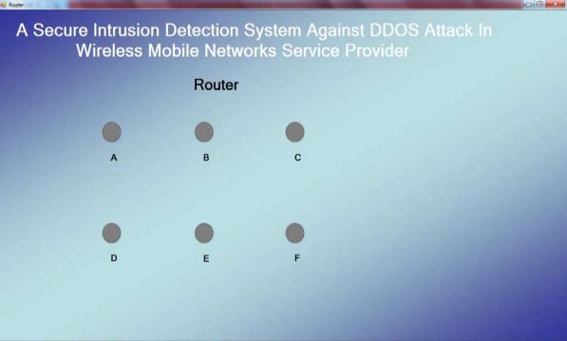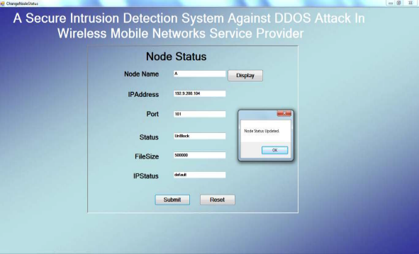

Implementation is the stage of the project when the theoretical design is turned out into a working system. Thus it can be considered to be the most critical stage in achieving a successful new system and in giving the user, confidence that the new system will work and be effective.
The implementation stage involves careful planning, investigation of the existing system and it’s constraints on implementation, designing of methods to achieve changeover and evaluation of changeover methods.
Implementation is the stage in the project where the theoretical design is turned into a working system. The most critical stage is achieving a successful system and in giving confidence on the new system for the users, what it will work efficient and effectively.
The implementation process begins with preparing a plan for the implementation of the system. According to this plan, the activities are to be carried out in these plans; discussion has been made regarding the equipment, resources and how to test activities.
The coding step translates a detail design representation into a programming language realization. Programming languages are vehicles for communication between human and computers programming language characteristics and coding style can profoundly affect software quality and maintainability. The coding is done with the following characteristics in mind.
• Ease of design to code translation.
• Code efficiency.
• Memory efficiency.
• Maintainability.

- conclusion and Future work
We thoroughly explore the problem of malware distribution at large-scale networks. The solution to this problem is desperately desired by cyber defenders as the network security community does not yet have solid answers. Different from previous modeling methods, we propose a two-layer epidemic model: the upper layer focuses on networks of a large-scale networks, for example, domains of the Internet; the lower layer focuses on the hosts of a given network. This two-layer model improves the accuracy compared with the available single layer epidemic models in malware modeling. Moreover, the proposed two-layer model offers us the distribution of malware in terms of the low layer networks. We perform a restricted analysis based on the proposed model, and obtain three conclusions: The distribution for a given malware in terms of networks follows exponential distribution, power law distribution with a short exponential tail, and power law distribution, at its early, late, and final stage, respectively. In order to examine our theoretical findings, we have conducted extensive experiments based on two real-world large-scale malwares, and the results confirm our theoretical claims.

- references
[1] Mugdha Kirkire, Poonam Gupta” Intrusion Detection in Mobile Ad hoc Network” International Journal of Computer Science and Mobile Computing, Vol.3 Issue.2, pp. 869 876, February 2020.
[2] U. Sharmila Begam, Dr. G. Murugaboopathi “A Recent Secure Intrusion Detection System for Manets” International Journal of Emerging Technology and Advanced Engineering Vol 3, Special Issue 1, January 2021.
[3] Prajeet Sharma, Niresh Sharma, Rajdeep Singh, A Secure Intrusion detection system against DDOS attack in Wireless Mobile Ad hoc Network, International Journal of Computer Applications (0975 8887) Volume 41 No.21, March 2020.

